Android GPS

Android GPS

Non-invasive user location tracking

Jerry Jia

Vivek Kalia

Scott Plummer

Tyler Trepanier

Contents

Technical Report 2

Summary 2

Introduction 3

General Test Evaluations: 3

Iteration 1: Description of tests goes here 4

Test Environment: 4

Test Purpose: 4

Test Results 4

Test 1 – Fig 1: 4

Iteration 2: Description of tests goes here 5

Test Environment: 5

Test Purpose: 5

Test Results 5

Test 2 – Fig 1: 5

Iteration 3: Description of tests goes here 6

Test Environment: 6

Test Purpose: 6

Test Results 6

Test 3 – Fig 1: 6

Iteration 4: Description of tests goes here 7

Test Environment: 7

Test Purpose: 7

Test Results 7

Test 4 – Fig 1: 7

Conclusion of the resulting tests: 8

# Handy Guide on How to Track your User’s Location

## Purpose and Usage of this package

Thank you for your interest in using the Android GPS Package: The non-invasive user location tracking. The purpose of this package is to easily track multiple user’s whereabouts and inform of any location changes of the user for every 10 meters they travel.

All recipients of this advanced technology must have the android application installed on their smartphone. Once installed, their location will be always tracked even after they’ve “closed” it. Amazing! Now, there won’t be any chances that your users will hide their location when they are out and about while on the job!

**NOTE: Your intended recipient must have an Android Device using an Android SDK of lollipop or higher.**

### Basic Android Usage

Once the application is installed, the user will be required to log into the application, provided they have an account set up. It is your responsibility as the operator of the Server to add in new users. After logging in it will immediately track the user’s location once the phone has activated the program for the first time.

### Basic Server Usage

Simply run the server executable (instructions can be found below) and you’ll be able to keep track on the server you set up when the comfort of your office and the users can follow their movements on the phone itself!

## Required tools

* An operational apache server.
* An android smartphone using the Android Lollipop or higher build for each intended user (sharing phones is not recommended).
* The most recent version of Android Studio and a computer to run Android Studio.
* A USB cord that can connect your phone to your computer.

## Installation Guide

### Server Installation

1. Depending on how your server is structured, your apache server set-up will vary but this website will provide a good basis on basic server installation and usage instructions: <http://docs.aws.amazon.com/AWSEC2/latest/UserGuide/putty.html>
2. For program installation, we have included a zip file that contains the server code which you will unzip into the desired server directory.
3. There is a Makefile inside of the server’s terminal that we can use. Using the server’s terminal and file directory, type in “make” and the program “*Server”* will be created.
4. For however long you wish to run the server, simply type in “*./Server*” and the server will receive and handle the incoming data.

### Android Installation

1. In order to install the application onto your phones, install Android Studio on your computer. (Refer to <http://developer.android.com/sdk/installing/index.html?pkg=studio>, for a full guide on how installation instructions and recommended settings).
2. 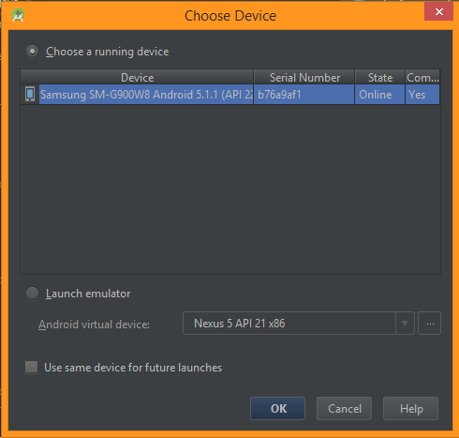Unzip the android folder and open the folder as a new Android Studio Project  
     
   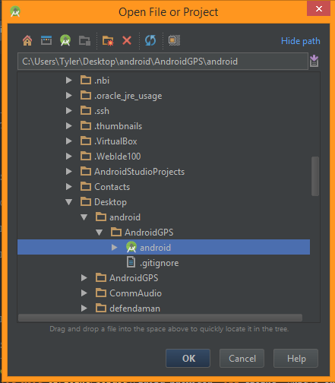
3. Once the project is fully built and loaded hit the run button.
4. A new window will pop up and show you a list of available device, select your phone and press OK.
5. The application will be successfully installed once it displays on your phone.

## Troubleshooting

### The website has stopped receiving updates from the phone…

There are many reasons that this can happen so we will break down the reasons into:

1. **The android phone is no longer operational**  
   Restart your phone, there is a known bug with the location manager in the older models of the android phone. Usually this solves the problem.
2. **A user shut off the android phone**  
   Solution: Force the phone to turn on through whatever means possible to you and restart the application.
3. **Your website may be down**Solution: Check your internet connection and upgrade your internet.

### Google Maps is not displaying on the webpage…

You do not have internet access to your apache server, try restarting your server or call your service provider for assistance.

# Android GPS Device Design

## Android Device Visual Design



## Android Device Pseudocode Design

### Initialize GUI

* Create text inputs for IP username and password
* Create button for connection
* if user enters valid IP and username/password
  + call Retrieve user information

### Retrieve user information

* Retrieve user IP address, username, and password from text inputs
* Store into variables
* Create socket for server connection
* call Retrieve user location

### Retrieve user location

* Get the users current location
* if user location has changed or first time getting location
  + call send data

### Send user data

* Send data to the server
* call Retrieve user location

# Server

## Server Visual Design



## Server Pseudocode Design

### Initialize TCP socket

* create TCP socket
* allow other sockets to bind to this port, unless there is an active listening socket bound to the port already.
* bind socket
* listen for a maximum of 20 connection
* While the Server is active
  + Wait for Incoming Data

### Accept New Client

* Accept the client from the listening socket
* Add the client to the list of clients connected
* Create a file dedicated to that client with read/write privileges to store all new GPS data.

### Wait for Incoming Data

* Wait for data to arrive on socket
* Determine which socket has data
* If the listening socket has data, Accept New Client
* If a connected socket has data, Collect New Connected Client data

### Collect New Connected Client data

* Receive the new data arriving on the client’s pre-connected socket.
* Connect to the MYSQL database
* Write the user’s coordinates to the table
* Disconnect from the database

# Website Design

## Website Visual Display

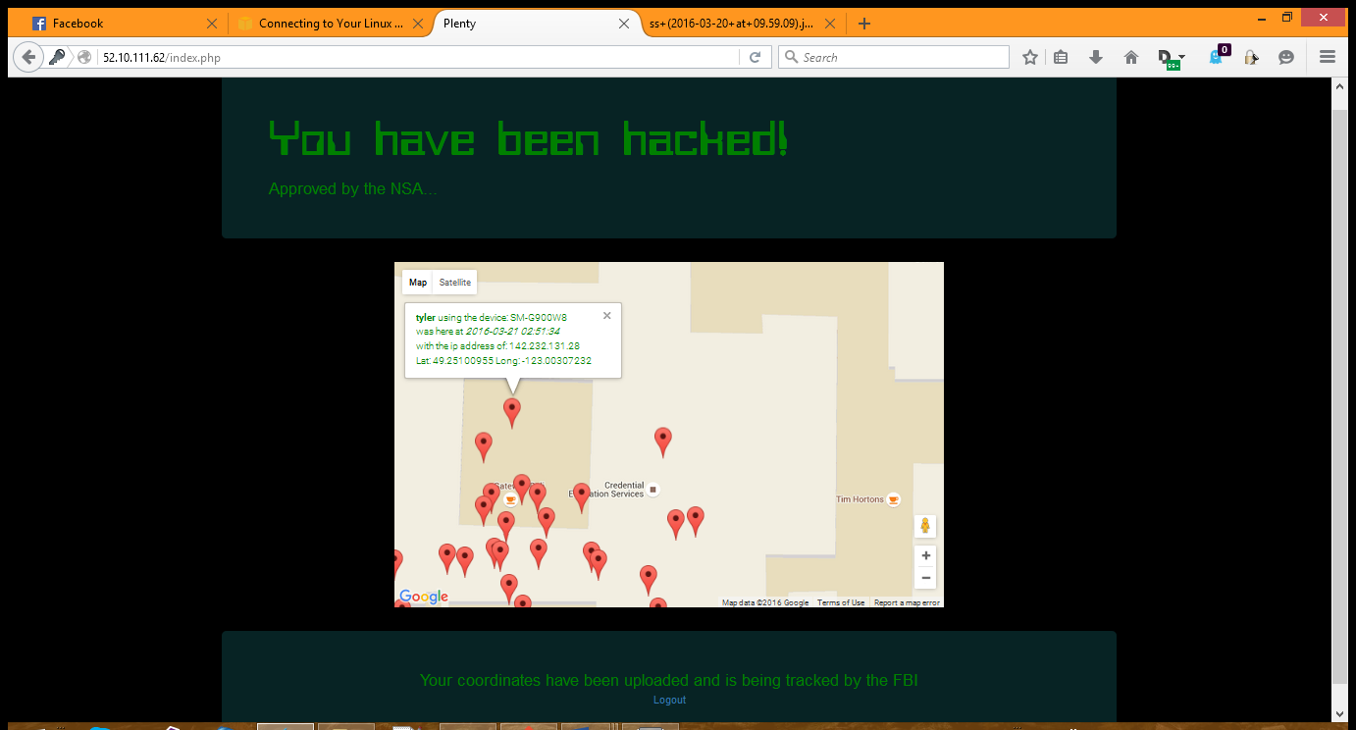

## Website Pseudocode Design

### Display Webpage

* Acquire the user’s login information
* Authenticate the user, denying any invalid credentials
* Display the initial landing page.
* In a continuous loop
  + Pull from the database the user’s coordinates.
  + Place any new coordinates into the Map
  + Update the map with the new markers

# Technical Report

## Summary

## Introduction

### General Test Evaluations:

Blah blah blah, we are looking for these results and in general the environment looks like blah blah blah

## Iteration 1: Description of tests goes here

### Test Environment:

We are outside blah blah blah.

### Test Purpose:

We are testing for success blah blah blah.

### Test Results

|  |  |  |  |  |
| --- | --- | --- | --- | --- |
| **Test #** | **Scenario** | **Expectations** | **Results** | **Conclusion** |
| 1 | Does it do the thing | It does the thing | It doesn’t do the thing | Pass / fail |
| 2 |  |  |  |  |
| 3 |  |  |  |  |
| 4 |  |  |  |  |
| 5 |  |  |  |  |
| 6 |  |  |  |  |
| 7 |  |  |  |  |
| 8 |  |  |  |  |
| 9 |  |  |  |  |
| 10 |  |  |  |  |
| 11 |  |  |  |  |
| 12 |  |  |  |  |
| 13 |  |  |  |  |
| 14 |  |  |  |  |
| 15 |  |  |  |  |
| 16 |  |  |  |  |
| 17 |  |  |  |  |

### Test 1 – Fig 1:

## Iteration 2: Description of tests goes here

### Test Environment:

We are outside blah blah blah.

### Test Purpose:

We are testing for success blah blah blah.

### Test Results

|  |  |  |  |  |
| --- | --- | --- | --- | --- |
| **Test #** | **Scenario** | **Expectations** | **Results** | **Conclusion** |
| 1 | Does it do the thing | It does the thing | It doesn’t do the thing | Pass / fail |
| 2 |  |  |  |  |
| 3 |  |  |  |  |
| 4 |  |  |  |  |
| 5 |  |  |  |  |
| 6 |  |  |  |  |
| 7 |  |  |  |  |
| 8 |  |  |  |  |
| 9 |  |  |  |  |
| 10 |  |  |  |  |
| 11 |  |  |  |  |
| 12 |  |  |  |  |
| 13 |  |  |  |  |
| 14 |  |  |  |  |
| 15 |  |  |  |  |
| 16 |  |  |  |  |
| 17 |  |  |  |  |

### Test 2 – Fig 1:

## Iteration 3: Description of tests goes here

### Test Environment:

We are outside blah blah blah.

### Test Purpose:

We are testing for success blah blah blah.

### Test Results

|  |  |  |  |  |
| --- | --- | --- | --- | --- |
| **Test #** | **Scenario** | **Expectations** | **Results** | **Conclusion** |
| 1 | Does it do the thing | It does the thing | It doesn’t do the thing | Pass / fail |
| 2 |  |  |  |  |
| 3 |  |  |  |  |
| 4 |  |  |  |  |
| 5 |  |  |  |  |
| 6 |  |  |  |  |
| 7 |  |  |  |  |
| 8 |  |  |  |  |
| 9 |  |  |  |  |
| 10 |  |  |  |  |
| 11 |  |  |  |  |
| 12 |  |  |  |  |
| 13 |  |  |  |  |
| 14 |  |  |  |  |
| 15 |  |  |  |  |
| 16 |  |  |  |  |
| 17 |  |  |  |  |

### Test 3 – Fig 1:

## Iteration 4: Description of tests goes here

### Test Environment:

We are outside blah blah blah.

### Test Purpose:

We are testing for success blah blah blah.

### Test Results

|  |  |  |  |  |
| --- | --- | --- | --- | --- |
| **Test #** | **Scenario** | **Expectations** | **Results** | **Conclusion** |
| 1 | Does it do the thing | It does the thing | It doesn’t do the thing | Pass / fail |
| 2 |  |  |  |  |
| 3 |  |  |  |  |
| 4 |  |  |  |  |
| 5 |  |  |  |  |
| 6 |  |  |  |  |
| 7 |  |  |  |  |
| 8 |  |  |  |  |
| 9 |  |  |  |  |
| 10 |  |  |  |  |
| 11 |  |  |  |  |
| 12 |  |  |  |  |
| 13 |  |  |  |  |
| 14 |  |  |  |  |
| 15 |  |  |  |  |
| 16 |  |  |  |  |
| 17 |  |  |  |  |

### Test 4 – Fig 1:

## Conclusion of the resulting tests:

It work good, plz use. Also this doc is awesome.